

Karthika, East Street,

Kazhakuttom P.O,

Thiruvananthapuram,

Kerala, India. PIN 695582

Tel: +91 83049 80878

Email: jayachandran.cs@tollant.com

PROJECT   
PROPOSAL

**Customer Feedback Application Development**

|  |  |
| --- | --- |
| **Prepared for:**  Sreejith **Company Name**  Mob:  Email: | **Submission Date:**  31st July 2017  **Proposal ID:** MA/TOL/31072017/1 |

___________________________________________________________________________________________________________________________________________  
Conﬁdentiality Notice: This Proposal is conﬁdential and contains proprietary information and intellectual property of Tollant. Neither this proposal nor any of the information contained herein may be reproduced or disclosed under any circumstances without the express written permission of Tollant.

© 2017 by Tollant Systems International Pvt. Ltd. All rights reserved. Confidential.

___________________________________________________________________________________________________________________________________________

Project Contacts

|  |  |
| --- | --- |
| Client Information | |
| Project Name | Mobile Application Development |
| Client Name |  |
| Client Address |  |
| Phone Number |  |
| Contact Person |  |
| Contact Person Email |  |
| Contact Person Phone Number |  |
| Contact Person Fax Number | - |
| Tollant Information | |
| Contact Person | Jaya Chandran CS |
| Contact Person Phone Number | +91 83049 80878 |
| Contact Person E-Mail | Jayachandran.cs@Tollant.com |
| Address | Karthika, East Street,  Kazhakuttom P.O,  Thiruvananthapuram,  Kerala, India. PIN 695582 |
| Project Information | |
| Proposed Technology/Methodology | Android / Web Based Application Development |
| Anticipate Start Date | NA |
| Proposal Valid For | 30 Calendar days from the submission of the proposal |

**Table of Content**

1 Introduction 4

1.1 Project Overview 4

2 Features 5

3 Technology Solution 6

3.1.1 Web Hosting 6

3.1.2 Browser Compatibility for Web Admin 6

4 Assumptions 7

5 Out of Scope 7

6 Project Effort & Timeline 8

6.1 Effort 8

7 Commercial 9

8 Payment Terms 10

9 Miscellaneous 10

9.1 Acceptance Criteria 10

9.2 General Terms and Conditions 10

9.3 Dependencies 11

# Introduction

**Tollant is pleased to submit this proposal for developing a Tablet Application (Android) based Customer Feedback Application for Raviz Hotel.**

Using the Tab based application the client can easily capture customer feedback through Android tablets and get powerful reporting, intelligent insights.

## Project Overview

Tollant with its technology partner Verbat, is a team of Digital Technology experts including consultants, web developers, graphic designers, programmers, marketing and SEO experts. Our specialty is creating modern, interactive, responsive, Custom Applications. **The project is to design and develop a Tab based Android Application with a Web Based Admin part:**

* Android based feedback form for customers to put their feedback (Tablet Portrait mode)
* An Web-based Admin area for managing feedback information and view the feedback status and reports

# Features

1. **Admin Area**
   1. Login
   2. Dashboard
   3. Survey Category Master
   4. Survey Questions and Options Master
   5. Reports (3 Reports)
   6. Customer Details
2. **Android Front End**
   1. **Enter Customer Details**
      1. Customer Name
      2. Gender
      3. Customer Date of Birth
      4. Customer Wedding Anniversary
      5. Customer Mobile No
      6. Customer Email
      7. Customer State
      8. Customer Country
   2. **Feedback Form**
      1. **Food**
         1. Portion size
         2. Flavor
         3. Presentation
         4. Value for money
         5. Choice
         6. Freshness
      2. **Service**
         1. Friendly
         2. Professional
         3. Explanation of menu
         4. Time taken to served
         5. Account settlement
      3. **Venue**
         1. Atmosphere
         2. Cleanliness of venue
         3. Staff presentation

# Technology Solution

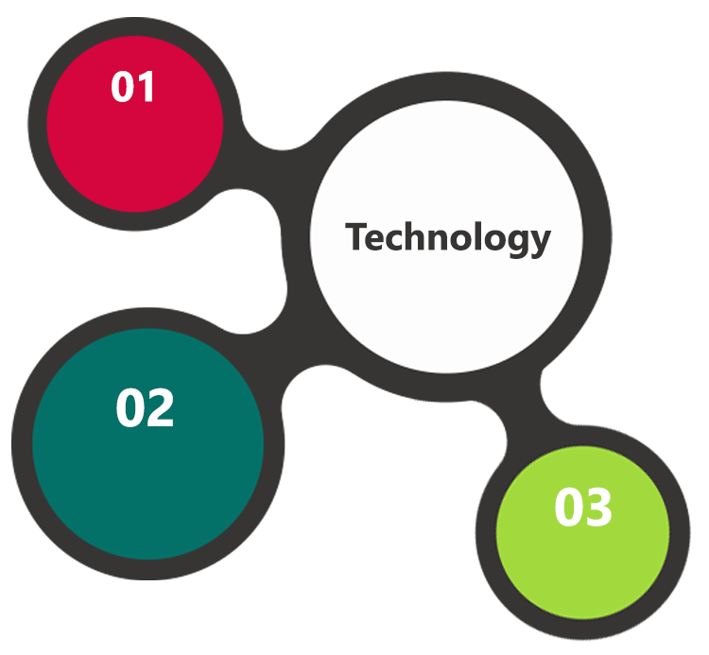

Android

ASP.Net  
IIS  
MSSQL DB

HTML 5  
JavaScript  
CSS 3

### Web Hosting

We have tie up with renowned hosting service providers in America and can

* Guarantee 99.9% uptime.
* Have strong security features
* Provide detailed visitor statistics
* Respond quickly to support requests.

### Browser Compatibility for Web Admin

* Chrome version: 56
* Firefox version: 51

# Assumptions

The proposed solution is based on the following assumptions to be read along with the General Terms & Conditions mentioned in this document

* Branding of the application shall be provided by the client
* Client shall provide licensed images and logos in specified size & format
* The application shall be designed only for Android

# Out of Scope

Following are considered to be out of scope while creating this proposal.

* Purchase of images, fonts
* Purchase of Theme
* Procuring Payment gateway service
* Any language other than English
* Integration with any other systems
* Disaster recovery for web hosting
* Annual Maintenance Contract

# Project Effort & Timeline

## Effort

The effort estimated for delivering the design and the prototype is **07 days** and the fully developed Mobile Android App with Web based Admin is **13 days.** In total, **20 Indian working days.**

# Commercial

**Android App Development**

|  |  |
| --- | --- |
| **Description** | **Cost (INR)** |
| Design and Develop Customer Feedback Android App with Web Admin | 1,20,000.00 |

**Web Hosting**

|  |  |
| --- | --- |
| **Description** | **Cost (INR)** |
| Hosting of the Web Admin Application (Yearly) | 15,000.00 |

**Shared Hosting Specification**

* Windows OS
* 2 GB Quota
* 20 GB Monthly Bandwidth
* ASP.Net
* MS SQL DB Standard

# Payment Terms

* 20% of total project value to be paid as advance along with the purchase order
* 30% of total project value to be paid on confirmation of the Design & prototype
* 40% of the total project value to be paid on completion of development and UAT Confirmation
* 10% of the total project value to be paid before going Live

# Miscellaneous

## Acceptance Criteria

* UAT sign off should happen within 14 Days from the release and the acceptance confirmation needs to be mailed to Tollant failing which Tollant will consider the project as approved by the client.
* Any comments or reason for rejection need to be documented and the same needs to be sent as an email from the official mail id of client to Tollant.

## General Terms and Conditions

* Offer Valid for 30 calendar days from the date of submission of the Proposal
* An average of 20 working days are assumed in a month
* The Mobile App will work only in Kitkat Ver 19 and above
* **The compatible design is Android Tablet 7” – Portrait mode**
* The app will be provided in APK format
* The device should have Internet connectivity
* The app will be tested in Samsung Galaxy, Redmi Tab (Size 7”)
* Tollant reserves the right to amend the terms of this proposal, should the SOW terms, functional features and functionalities change during the course of the project
* **The mobile app shall be built on the agreed use-case, wireframe. Any customization to the confirmed and purchased theme shall be executed through a defined change management process between both parties**
* All Source Code and other project artefacts would adhere to the Tollant document templates and internal coding standards
* Acceptance criteria shall be based on the clauses which were mutually discussed between Tollant and client at the Requirement Analysis phase and the same will be documented and approved by both parties through official emails
* Final deployment to production server pursuant to completion of all payments
* Tollant shall provide a bug ﬁx warranty at no additional cost for 30 days from the date of acceptance of the project, for correction of any errors in the developed application that may be attributed to Tollant
* If deployment is at the client’s server, responsibility of deploying the delivered built or any other interim releases onto the production environment after conducting the necessary acceptance testing will lie with Tollant unless otherwise agreed. However any support services shall be contracted separately for deployment.
* Tollant shall not be held responsible for any non-performance of the application if in case the Web application is hosted on the clients environment

## Dependencies

* During the requirement gathering phase, authorized personnel from the Client’s side is expected to be available for discussion and finalizing the HLD (High Level Design), before development commences
* All queries regarding the client requirement and any queries which may hinder the project advancement at any stage should be answered by the client within 24 hours from the time of initiation, failing which the time delay will get added to the actual effort which was estimated
* Tollant assumes that all sign-offs from Client will be provided within agreed and specified timeframe.
* Client will provide all the necessary contents, both text and image, before starting the project in the format suggested by Tollant
* The client should provide the relevant information and data well in time for the execution of a related activity. Non- availability of this information or data may lead to an interruption of work which may result in a delay in delivery as well as additional costs to the client

**Sharjah Customs**

**UAE University**

Transportation

**Canada Cartage**

Construction

Services

We look forward to hearing from you soon and hope that you will give us the privilege to work with you in meeting your business goals. Thank you.

©   
2017. All Rights Reserved   
Tollant Systems   
www.tollant.com